14. **PREDICTION OF CATEGORICAL DATA USING SMO ALGORITHM USING WEKA.**

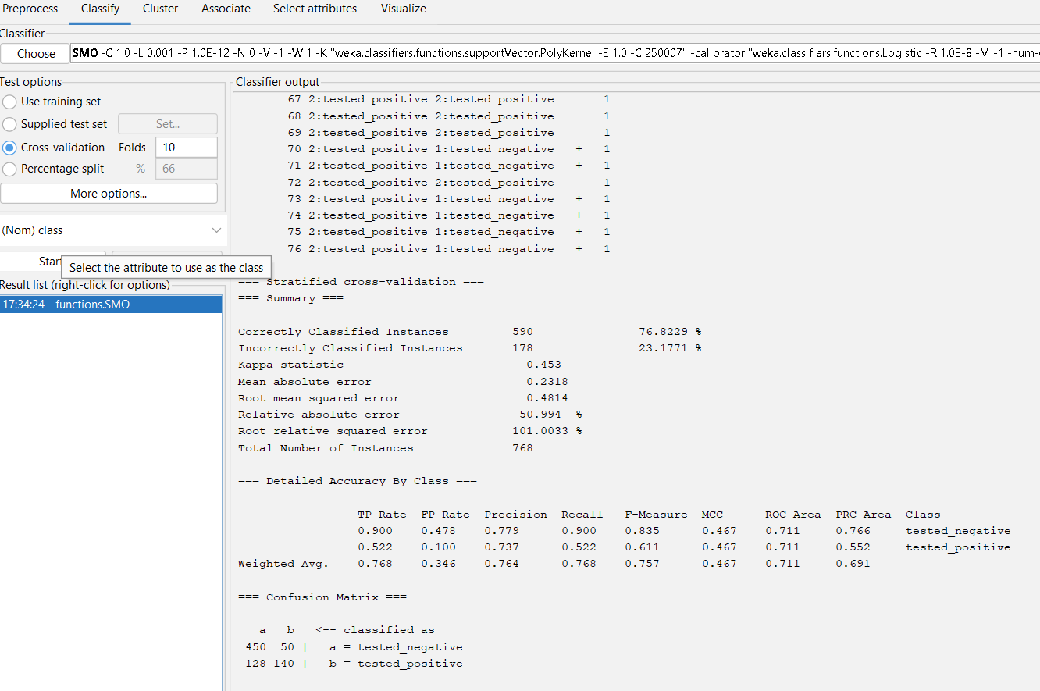

The output information of diabetes data using smo..